OS LAB
PRACTICAL-12
Implement the Producer-Consumer problem using counting semaphores and POSIX threads. Evaluate synchronization correctness and system throughput under different buffer sizes.

Design a deadlock scenario involving multiple threads competing for shared resources. Demonstrate deadlock occurrence, identify the four necessary conditions for deadlock, and implement a deadlock prevention strategy using resource ordering
producer_consumer.c

#include <stdio.h>
#include <stdlib.h>
#include <pthread.h>
#include <semaphore.h>
#include <time.h>

#define ITEMS 1000000

int *buffer;
int size;
int in = 0, out = 0;

sem_t empty, full;
pthread_mutex_t mutex;

void *producer(void *arg) {
for (int i = 0; i < ITEMS; i++) {
sem_wait(&empty);

pthread_mutex_lock(&mutex);
buffer[in] = i;
in = (in + 1) % size;
pthread_mutex_unlock(&mutex);

sem_post(&full);
}
return NULL;
}

void *consumer(void *arg) {
for (int i = 0; i < ITEMS; i++) {
sem_wait(&full);

pthread_mutex_lock(&mutex);
int item = buffer[out];
out = (out + 1) % size;
(void)item;
pthread_mutex_unlock(&mutex);

sem_post(&empty);
}
return NULL;
}

int main(int argc, char *argv[]) {
if (argc != 2) {
printf("Usage: %s <buffer_size>\n", argv[0]);
return 1;
}

size = atoi(argv[1]);
if (size <= 0) {
printf("Buffer size must be positive.\n");
return 1;
}

buffer = malloc(sizeof(int) * size);
if (buffer == NULL) {
perror("malloc");
return 1;
}

pthread_t p, c;
sem_init(&empty, 0, size);
sem_init(&full, 0, 0);
pthread_mutex_init(&mutex, NULL);

struct timespec start, end;
clock_gettime(CLOCK_MONOTONIC, &start);

pthread_create(&p, NULL, producer, NULL);
pthread_create(&c, NULL, consumer, NULL);

pthread_join(p, NULL);
pthread_join(c, NULL);

clock_gettime(CLOCK_MONOTONIC, &end);

double elapsed = (end.tv_sec - start.tv_sec) +
(end.tv_nsec - start.tv_nsec) / 1e9;

printf("Buffer size: %d\n", size);
printf("Items produced and consumed: %d\n", ITEMS);
printf("Elapsed time: %.6f seconds\n", elapsed);
printf("Throughput: %.0f items/second\n",
ITEMS / elapsed);

pthread_mutex_destroy(&mutex);
sem_destroy(&empty);
sem_destroy(&full);
free(buffer);

return 0;
}

OUTPUT
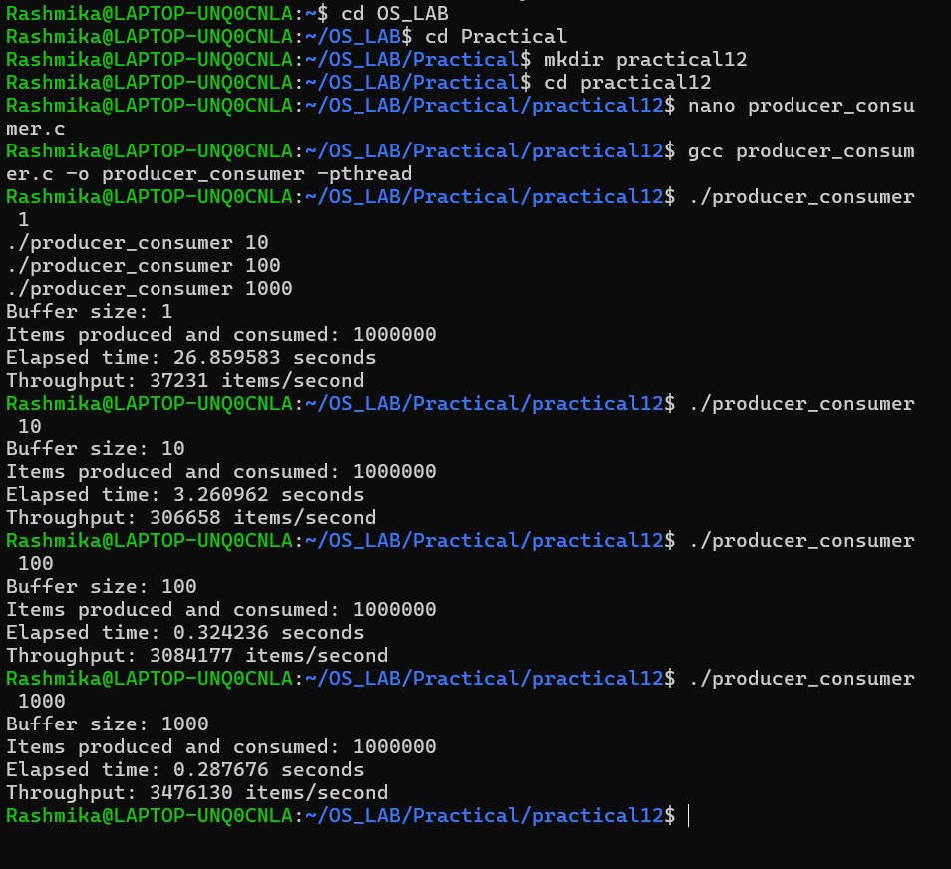

deadlock.c

#include <stdio.h>
#include <pthread.h>
#include <unistd.h>
pthread_mutex_t A = PTHREAD_MUTEX_INITIALIZER;
pthread_mutex_t B = PTHREAD_MUTEX_INITIALIZER;
void *thread1(void *arg) {
pthread_mutex_lock(&A);
printf("Thread 1 acquired Resource A\n");
sleep(1);
printf("Thread 1 waiting for Resource B\n");
pthread_mutex_lock(&B);
printf("Thread 1 acquired Resource B\n");
pthread_mutex_unlock(&B);
pthread_mutex_unlock(&A);
return NULL;
}
void *thread2(void *arg) {
pthread_mutex_lock(&B);
printf("Thread 2 acquired Resource B\n");
sleep(1);
printf("Thread 2 waiting for Resource A\n");
pthread_mutex_lock(&A);
printf("Thread 2 acquired Resource A\n");
pthread_mutex_unlock(&A);
pthread_mutex_unlock(&B);
return NULL;
}
int main() {
pthread_t t1, t2;
setbuf(stdout, NULL);
pthread_create(&t1, NULL, thread1, NULL);
pthread_create(&t2, NULL, thread2, NULL);
pthread_join(t1, NULL);
pthread_join(t2, NULL);
pthread_mutex_destroy(&A);
pthread_mutex_destroy(&B);
return 0;}
OUTPUT
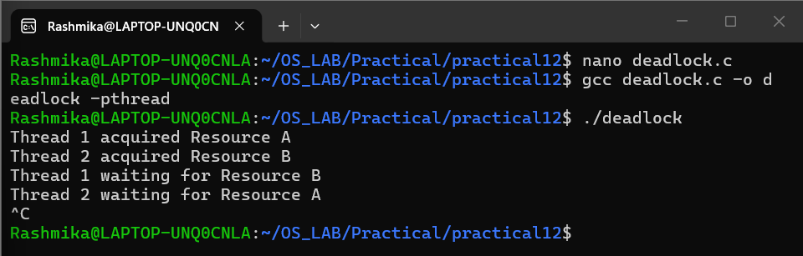
deadlock_prevention.c

#include <stdio.h>
#include <pthread.h>
pthread_mutex_t A = PTHREAD_MUTEX_INITIALIZER;
pthread_mutex_t B = PTHREAD_MUTEX_INITIALIZER;
void *work(void *arg) {
int id = *(int *)arg;
/* Always acquire A before B */
pthread_mutex_lock(&A);
printf("Thread %d acquired Resource A\n", id);
pthread_mutex_lock(&B);
printf("Thread %d acquired Resource B\n", id);
printf("Thread %d is using both resources\n", id);
pthread_mutex_unlock(&B);
pthread_mutex_unlock(&A);
printf("Thread %d released both resources\n", id);
return NULL;
}
int main() {
pthread_t t1, t2;
int id1 = 1, id2 = 2;
setbuf(stdout, NULL);
pthread_create(&t1, NULL, work, &id1);
pthread_create(&t2, NULL, work, &id2);
pthread_join(t1, NULL);
pthread_join(t2, NULL);
pthread_mutex_destroy(&A);
pthread_mutex_destroy(&B);
printf("Completed without deadlock.\n");
return 0;
}
OUTPUT
